Computer Language Coding Concepts

Beware of Active Command References in Commands in a Diagram
The rule, that advises you to beware of what you are doing, when you are using an active command reference inside a command, was already covered conceptually in the article Beware of Active Command References in Commands. The current article further explains it using diagrams.

You have to be aware, that when you use an active command reference, the active command reference may already have been executed.

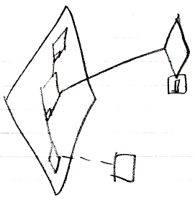

Or that you may be waiting on an external execution to finished.

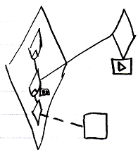

If the external execution won’t finish, then the referring procedure is stuck.

If the external command object is an inactive command object, it will never execute, and the command will truly be stuck. A warning should be generated then.

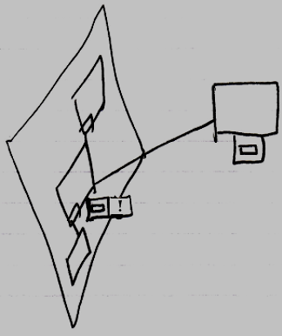

It is not the rule, to beware of any active command reference. It is the rule to just always beware of them in a parent command. An object can contain an active command reference, in order to for instance allow a user to carry around a reference to an active command, executing on a site somewhere.

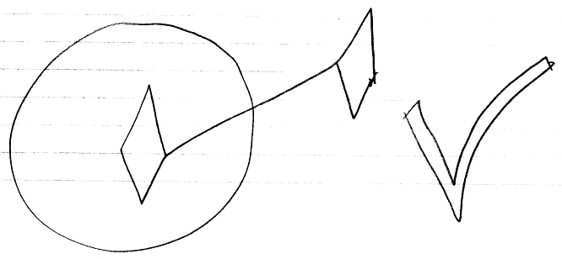

See also: Commands Never Contain Active Command References, Commands

Author & Copyright: Jan-Joost van Zon Date: August 25, 2008 – August 25, 2008 Location: Oosterhout, The Netherlands Status: Finished

